**Overview:**

Preparing for Your Self-Administered and Official PFT

The FBI Special Agent position requires a commitment to physical fitness as part of daily life. Applicants will take a

self-administered PFT (after passing Phase I testing) and take an official standard PFT at least two times during the

application period and/or at the FBI Academy. Specifically:

»» At your Processing FBI Field Office shortly after

passing Phase II.

»»No more than 60 days prior to reporting to the

Basic Field Training Course (BFTC) at the FBI Academy.

*If an applicant is scheduled to report to a BFTC within*

*60 days of passing his or her post-Phase II PFT,*

*an additional PFT is not required.*

»» At least once while at the FBI Academy during the

first week of the BFTC. *The test, scoring scale and protocol are the same.*

The standard PFT consists of four main events, with a fifth event for candidates in the Tactical Recruitment Program

(TRP). These events were chosen because they accurately measure an individual’s overall fitness level relative to the

essential tasks performed by FBI Special Agents. The events are administered in the following order with no more than five minutes of rest in between each event:

1. Maximum number of continuous sit ups in one minute.
2. Timed 300-meter sprint.
3. Maximum number of continuous push ups (untimed).
4. Timed 1.5-mile run.
5. Maximum number of pullups (untimed).*

*\*Note: Only candidates in the TRP will complete this event.*

Each event must be performed precisely according to the strictly defined protocol in order to be scored. In order to

pass the standard PFT, applicants must achieve a minimum cumulative score of 12 points in the first four events, with

at least one point in each of the first four events; therefore, it is possible for an applicant to receive a score of 12 (or

more) and still fail the standard PFT by failing one of the individual events. TRP applicants must achieve a minimum

score of 20 points and must score at least one point in each of the five events to pass the TRP PFT.

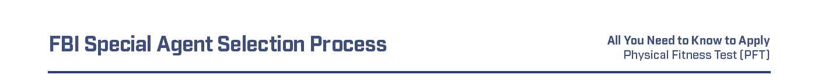**Protocol and Scoring Guide:**

Sit Ups:

The candidate lies on back with tops of shoulder blades touching the floor; arms crossed over chest with fingers

in contact with the top of the shoulder (trapezius muscle or seam on some T-shirts). Knees are bent at a 90-degree

angle with the feet placed flat on the floor (feet are held in place by a partner with the partner’s hands at the tongue

of the trainee’s shoes and knees on the trainee’s toes).

Candidate raises upper body until the elbows touch mid-thigh, then returns to the starting position (the tops of

the shoulder blades must touch the floor) to complete the repetition. Hips must remain in contact with the ground

throughout the repetition. This is a timed one-minute continuous motion exercise; if a candidate pauses before the

minute is up, he or she forfeits the rest of the minute.

Scoring Scale for One-Minute Sit Ups

|  |  |  |
| --- | --- | --- |
| **Score** | **Female Range** | **Male Range** |
| -2 | 29 and below | 31 and below |
| 0 | 30-34 | 32-37 |
| 1 | 35-36 | 38 |
| 2 | 37-40 | 39-42 |
| 3 | 41-42 | 43-44 |
| 4 | 43-46 | 45-47 |
| 5 | 47-48 | 48-49 |
| 6 | 49-50 | 50-51 |
| 7 | 51-52 | 52-53 |
| 8 | 53-54 | 54-55 |
| 9 | 55-56 | 56-57 |
| 10 | 57 and over | 58 and over |

